Code Manual
Click the icon in the red box to open a selection of all materials
Click on the Senior-Project-Code if current material selected isn’t the material you need.
Select required material, available are Concrete, Wood, Masonry
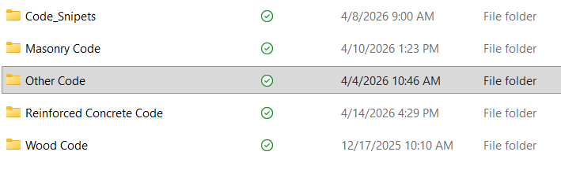
To Run either Wood or Masonry click the run button.
Then answer pop up questions.
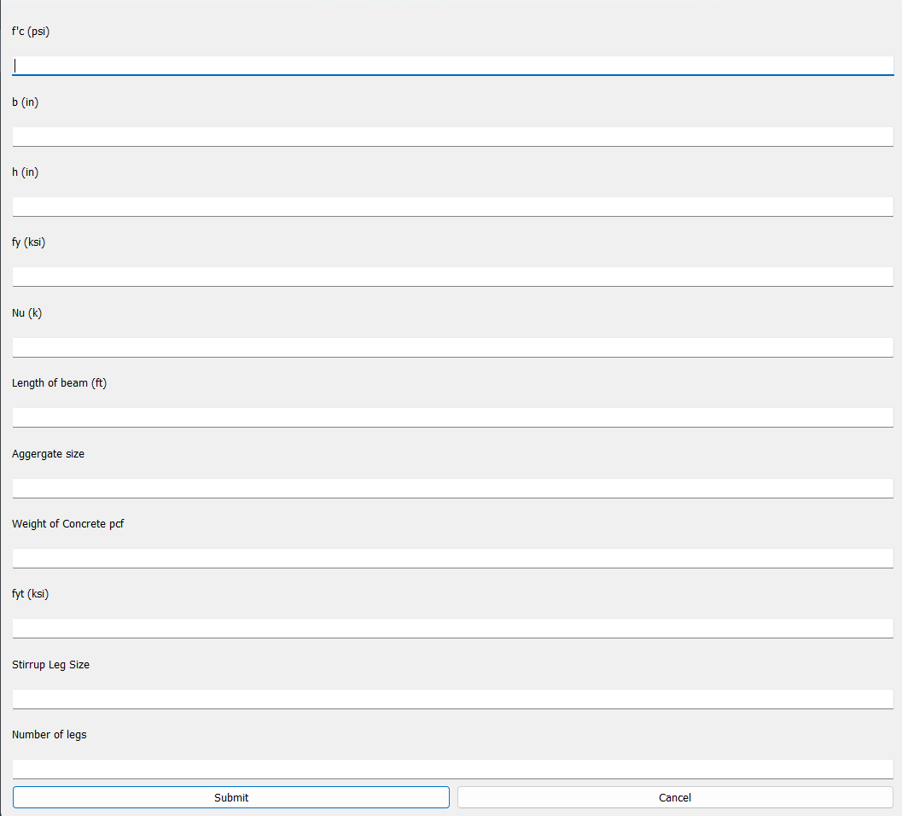

Note: For Masonry there is no UI, go through the top half where the notes say to edit and change the input values.

After printout in Console copy paste code into any word doc of your choosing, ensure that you also take any plots with it.
